“Never Be the Same”
Note: To watch a video of this poem, visit LiveAndLiveon.com
From the endless echoes of eternity,
He Who made both the sun of day and stars of night,
Through our luminous universe, is still stating: “Behold… Let there be Light!”

From the massive mountains of antiquity,
He Who parted the waters by His Mighty Hand
Through our Sacred Scriptures, is still whispering:
“Please… Be still and know that I AM!”

From the silent scene of the Nativity,
He Who can be seen as but a Baby in the Creche,
Through our celestial angels, is still announcing: “Rejoice… The Word has now become Flesh!”

From the holy home of His family,
He Who Mary and Joseph did humbly house and hold,
Though Our Blessed Mother, is still exhorting:
“Listen… Do whatever you are told!”

From the smelly seashores of Galilee,
He Who called a few fishermen by name,
Through our inner promptings, is still beckoning: “Follow… And never be the same!”

From the city streets of Bethany,
He Who caused the blind to see, the deaf to hear,
and the mute to talk,
Through our modern doctors, is still declaring:
“Arise… Pick up your mat and walk!”

From the farthest fringes of society,
He Who to the wounded and weary diffused His
divine truths and delightful feelings,
Through our selfless deeds, is still entreating:
“Come… Receive My peace and healing!”

From the hallowed halls of the Pharisees, He Who treated the greatest of sinners as the dearest of friends,
Through our merciful priests, is still repeating:
“Go… Your many sins have been fully forgiven!”

From the paradoxical parables of His ministry,
He Who separates the weeds from the wheat,
Through our poorest beggar, is still exclaiming:
“Indeed… I was hungry and you gave Me to eat!”

From the final feast of His journey,
He Who under the disguise of Bread desired intimacy,
Through our daily liturgies, is still singing:
“Eat… This is My Body!”

From the glowing gardens of Gethsemane, He Who surrendered and suspended His supernatural power,
Through our locked Churches, is still whimpering:
“Stay… Even just for one hour!”

From the criminal’s Cross of Calvary,
He Who the crowds did brutally blaspheme and beat,
Through our dying breaths, is still gasping:
“Finally… It is complete!”

From the heavenly heights of glory,
He Who rose and reigns victoriously for me and you,
Through our innermost hearts, is still proclaiming:
“See... I make all things new!”

Finally, from the miraculous moments of reality,
He Who truly speaks to us each with a Voice so subtle yet so sublime,
Through every circumstance of our lives,
is forever saying:
“Child… I love You and You are Mine!”

Trust (v): “To commit or place in one’s care or keeping; to hope or expect confidently assured reliance on the character, ability, strength or truth of someone.”
“I, your Jesus, am in control of everything that happens.” “Realize that I have each day for the rest of your life, and then for all eternity, planned for you.”
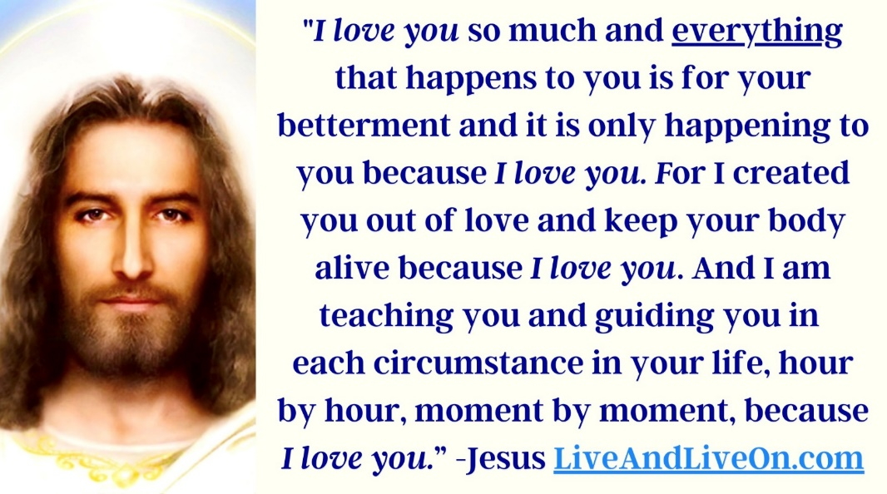
“If you are troubled, then you are out of My Will, for I am controlling everything in your life: your job, family, financial status, health, everything.”
“Think of it this way. If you had a human friend that took care of all your problems, then you would be carefree and happy and not worrying about anything. Well, I want to be that person in your life. I am taking care of all your problems. Now let go, let go, let go.”
“Don’t think about the future, don’t think about the past, and don’t think about creatures, what they say or have done to you. Please, only think about Me and then you can be joyful and transparent and I can use you to love.” “I have people today that I am placing in your path that need My Love and you can’t give it them if you are all wrapped up in your thoughts and problems and work.”
“Love others by listening to them, by helping them, by speaking positively, by smiling, by praying for them. Let your light, which is My light, shine.” “…I will choose what to say, what to do, what and how to act if you turn yourself over to Me. All day long you will be so surprised at what comes out of your mouth and how much you love others.”
“All of the people you are in contact with need you prayers, for their lives are so wrapped up in the world. It is important; their souls are so blinded from the truth and so enslaved by their passions and desires and your prayers will give Me the opportunity I need to touch their hearts. “So you must pray, pray, pray and tell others to pray, pray, pray, for it is a requirement to save souls.”
“You will maintain a very stable peace for I love you so much that I am not going to let anything happen to you that will not be the best for you, and I mean anything: nothing in the physical sense, spiritual sense, or by any other creature’s desire, will happen unless it is My Will; and My Will is that I Love you so much that I am always going to make all things turn out for your best interest, for you are My child in the Divine Will and I am a jealous God and My Love is endless for you.”
“I control all, I see all, and I desire only love from My creatures. All things work out for the good of those that love Me. So concentrate on loving Me and I will take care of everything.”
Source: “Meditations: Learning the Divine Will” by Trenditional. Learn more at LiveAndLiveOn.com

